Forecasting of Fish Commodities and the Impact of Covid-19 in Metro Manila

Jediboy Betos  
*Technological University of the Philippines*Manila, Philippines  
jediboy.betos@tup.edu.ph

*Abstract*—The COVID-19 pandemic has impacted the over all economy in many sectors such as agriculture. In this study, the researcher analyzes the prices of fish commodities being sold in Metro Manila during the pandemic lockdowns. Using the relevant time series methodologies such as the Autoregressive Integrated Moving Average (ARIMA), the researcher establishes the hypothesis that the COVID-19 lockdowns have an impact on these prices. Based on the study’s findings, the fish commodities were affected by the lockdowns in specified months and even in the entire duration of the lockdown from October 1, 2019 to August 31, 2021.

Keywords—ARIMA, forecasting, interrupted time series, COVID-19, fish commodities

# Introduction

On December 2019, the first observed cases of the SARS-CoV-2 virus (COVID-19) were found in Wuhan, China [1]. As of January 2022, the total number of COVID-19 cases amount to over 313M worldwide while in the Philippines it amounts to over 3M cases [2]. The impact of this pandemic on the Philippines made its GDP drop to 9.5%, the lowest it has been since World War 2 [3]. The rapid spread of this virus has caused a global pandemic that continues to have an impact on livelihoods and global food security [4].

The COVID 19 pandemic and community quarantines has certainly affected the agricultural sector in terms of logistics and supply chain bottlenecks and in terms of food systems and availability as of July 2020, other external drivers such as pests and climate change are observed to have a more significant impact on food security in the Philippines [5]. Agricultural damages caused by typhoons amount to 4.6B PhP in the last quarter of 2020 [6]. Initially, during the first phases of lockdown supply chain transport was were faced with local government unit imposed transport restrictions and the suspension of public transport. One of the Department of Agriculture’s response to the pandemic for economic recovery of agribusinesses was the approval of the Expanded SURE Aid and Recovery Project for SURE Covid-19 financing program that prioritizes micro and small businesses as it plays a crucial role in ensuring food availability in Metro Manila and other urban centers [7]. After an agreement and a change of policy for food logistics, namely food and cargo pass, the government was successful in assuring the movement of goods and agro-inputs [8]. Most agribusinesses also report a decline in sales with the exception of direct online sellers and e-commerce after an initial round of panic buying. Prices were then showing volatility before and after ECQ followed by relatively stable prices [9].

In the face of the ongoing pandemic, a need to analyze and capture the causes of the COVID-19 spread is necessary when dealing with the economics of trade and the enforcement of trade policies for fair retail pricing of commodities. On a technical standpoint, there are difficulties and challenges with developing time series models employed by central bankers, economists, and practitioners for analyzing price fluctuations and inflation due to observations affected by the pandemic [10]. In this paper, the researcher analyzes the impacts of COVID 19 on the prices of fish commodities and validates accuracy with forecasting. Further, the researcher’s goal with this paper is to add to the literature that analyzes COVID 19 impacts to help in deriving conclusions based on existing methods. The methodology of this study aims to develop a time series model for analyzing and forecasting the prices of fish commodities with the dataset provided by the Philippines’ Department of Agriculture themselves.

# Related works

Daglis, Konstantakis, and Michaelides (2020) analyzed the global prices of wheat and oat markets using relevant time series causality testing models by Dufour and Renault and cross validated with forecasting using a Vector autoregressive model as a baseline [11]. Their results where then evaluated with three distinct measures of forecasting accuracy tests: mean absolute error, mean absolute percentage error, and root mean square forecasting error. Their findings imply that the COVID-19 provides statistically significant information for modeling that is indicative of the pandemic impact. It also gives evidence that accounting for observations of the COVID-19 pandemic greatly increases forecasting ability of relevant agricultural commodities.

Hung (2021) investigated crude oil prices and commodity markets from the pre-COVID-19 period (February 2018) to the early stages of the pandemic (May 2020) [12]. They analyzed the spillover effects and time-frequency correctness of crude oil prices and agriculture markets using spillover index of Diebold and Yilmaz and wavelet coherence approaches for the periods before the pandemic. Their research concludes that there is statistically more apparent return spillovers of crude oil and agricultural markets during the pandemic than before. They also revealed that there exists significant dependent patterns between crude oil and agricultural commodity markets that can provide prominent implications for policymakers.

The European Union (EU)’s agri-food markets are also examined to have a significant decrease in agri-food exports and imports during the 2nd and 3rd quarters of 2020. Hamulczuk and Skrpzypczyk (2021) examines the trade-balance significance of EU countries for changes in agri-food producer prices using a spatial partial equilibrium model [13]. They determined a deterioration in spatial integration of EU agri-food markets and is an indication of the COVID-19 pandemic causing a reduction in economic welfare. In their examination, one of the key driving forces of agri-food prices in the EU during the 2nd and 3rd quarters of 2020 was pandemic related food shortages and surpluses.

Goeb, et al. (2021) uses a simple empirical model to evaluate milling margins and paddy and rice prices in Myanmar [14]. As their analysis is descriptive and does not isolate causal impact, they framed their datasets into inputs (paddy before being processed) and outputs (head rice, broken rice, rice bran) from before and during the pandemic. Their findings suggests that Myanmar’s rice mills were affected the pandemic yet surprisingly showed resilience in the early stages of quarantine and thus milling margins were relatively unaffected. They note that paddy-to-rice margin changes were small and is not a major explanation for price changes. They do however see significant effects of increased demand to price changes of Myanmar’s exported rice variety.

Chitikela, et al. (2021) investigated the impact of COVID 19 on tomato supply and prices in India using an ARIMA intervention model and two AI-based intervention models--namely support vector regressions and artificial neural networks [15]. The models were evaluated using mean absolute percentage error for forecasting. The models confirmed a negative impact on the supply and a positive impact on the prices of tomatoes. This implies that spillover effects from the pandemic and the resulting increase of transportation contributed to the rising prices of tomatoes along with a lower degree of consumption. Their research also details empirical results from six specific models selected from their methodology. The performance of their ARIMA, ARIMA intervention, SVR, SVR intervention, ANN, and ANN intervention models were evaluated based on forecasting ability according to their modal errors training and test datasets. They’ve concluded that among the models used for analysis, ANN intervention model outperforms the others in both training and test data sets. Their purpose of using an AI-based model was to capture nonlinear and complex natures of their data and recommends that it can be used for potential effects of government programs and policies.

Ruan, Cai, and Jin (2021) uses a combination of time regression discontinuity design method (T-RD) and the difference-in-difference method (DID) in analyzing vegetable prices from wholesale markets in China and the effects of COVID-19 lockdowns. Their study was done to determine to evaluate the level and dispersion of vegetable prices accounting the effects of lockdown measures adopted by the Chinese government. Their results show that the lockdowns had a statistically significant effect on vegetable markets. The daily prices of cabbage increased by 46% on the initial phases of the lockdown to a peak of 65% by the 4th week of lockdowns before declining and normalizing back on the 10th week. Their conclusions confirm that disruptions of supply chains where the driving force of price surges and draw policy implications pertaining to prioritizing smooth flow of perishable products to markets.

# Materials and Methods

The daily prevailing prices of commodity goods are recorded by the Department of Agriculture [16]. The data was available in tabulated formats with retail prices per kilogram from each public market and a summarized column of high, low, prevailing and average prices for each specified commodity. The locations of the 13 public markets that were constantly monitored are from the major cities of Metro Manila. The range of the dataset used in this study are reflected by the parsable formats and the relevant consistency with regards to the start of the lockdowns in Metro Manila.

1. List of public markets

| Public Market | Municipality |
| --- | --- |
| New Las Piñas City Public Market | Las Piñas City |
| Guadalupe Public Market | Makati City |
| Public Market | Municipality |
| New Las Piñas City Public Market | Las Piñas City |
| Guadalupe Public Market | Makati City |
| San Andres Market | Manila City |
| Quinta Market | Manila City |
| Marikina Public Market | Marikina City |
| Pamilihang Lungsod ng Muntinlupa | Muntinlupa City |
| Pasay City Market | Pasay City |
| Pasig City Mega Market | Pasig City |
| Commonwealth Market | Quezon City |
| Muñoz Market | Quezon City |
| Mega Q-mart | Quezon City |
| Malabon Central Market | Malabon City |
| Pritil Public Market | Manila City |

There was a lot of inconsistency in the data such as missing dates and duplicates. For the gathered time series data, a good 23.96% are missing for Bangus, Tilapia and Local Round Scad, 37.10% for Alumahan and 71.38% for Imported Round Scad prices. According to the price monitoring, the missing data are an indication that the goods are not available in the market during the specific dates or that the markets are closed due to stringent lockdowns. Dong and Peng (2013) reviews that a good 15% to 20% of missing data is common and that new and improved ways of imputing data can provide statistically significant analysis [17]. However, there is yet to be an established acceptable amount of missing data as there are different assumptions to what can make data statistically biased. For this study, the researcher will maintain that only datasets whose missingness are 25% and below will be used which comes down to Bangus, Tilapia, and Local Round Scad.

1. Missingness of data from october 1, 2019 to august 31, 2021

| Commodity | Frequency | Missing | Percent Missing |
| --- | --- | --- | --- |
| Bangus | 457 | 144 | 23.96% |
| Tilapia | 457 | 144 | 23.96% |
| Alumahan | 378 | 223 | 37.10% |
| Local Round Scad | 457 | 144 | 23.96% |
| Import Round Scad | 172 | 429 | 71.38% |

According to the Labor Force Statistics (2001), imputation is the substitution of missing values [18]. Statistical approaches are already being used to handle imputation of missing data [19]. Interpolation is one of the methods for imputing data that assumes a relationship between missing and non-missing values. To keep a consistent frequency, the data was imputed using PANDAS time based interpolation which is supposed to work on daily and higher resolution data [20].

## Forecasting Methodlogy

The commodity prices are gathered as time series data. The study uses the Box-Jenkins model that is a systematic method of using integrated autoregressive and moving average terms to identify, fit, and forecast time series data [21]. The model is a combination of three process namely an autoregressive order of **p** (AR), an order of differencing **d** (I) to make the time series stationary, and an order of moving average terms **q** (MA)--identifying as ARIMA(**p,d,q**). The model is defined as

$$X_{t}=ϕ_{1}X_{t}-1+⋯+ϕ_{p}X_{t}-p+a_{t}-θ_{1}a_{t}-1-⋯-θ_{q}a_{t}-q$$

where $ϕ$ is the autoregressive parameters estimated, $θ$ are the moving average parameters, $α's$ are the random errors or residuals in the $X's$ as the original series. The constant terms are omitted depending on the developed model and the errors are generally assumed as following a normal distribution. The choice of determining the appropriate **p, d, q** and terms are the major challenges of using this model but it can be resolved by performing a series of steps that follows the Box-Jenkins methodology.

## Identifying the model

The Box-Jenkins methodology dictate that in developing an ARIMA model, the time series must be stationary, have the autocorrelation and partial autocorrelation analyzed for AR and MA estimation, fitted and checked for residual diagnostics, and further evaluated for additional AR and MA terms before reconstructing the model [22].

## Stationarity and Differencing

For an ARIMA model, the input time series needs to be stationary. A stationary time series is defined as having constant mean, variance, and autocorrelation over time. In other words, the properties of the time series should not depend on time [23]. There are a number of ways to determine if a series is stationary. A non-stationary time series would have trends, seasonality, and predictable patterns. There are also unit root tests that can determine if a time series is stationary regardless of presence of trends. For this study, the researcher will utilize the Augmented Dicky-Fuller (ADF) test which is used for testing stationarity and serial autocorrelation. The null hypothesis for this test assumes that a time series has a unit root. The ADF test is similar to the Dicky-Fuller test but adds lagged differences to the models. It is defined as

$$Δy_{t}= α+ βt + γy_{t}-1 + δ_{1}Δy_{t}-1 + ⋯+ δ_{p}-1 Δy_{t}-p+1 + ε_{t},$$

where $α$ is a constant, $β$ the coefficient on a time trend and p is the lag order of the autoregressive process. After determining if the time series is stationary or not, the order of differencing d is the number of times it is needed to be differenced until it is stationary. The necessary level of differencing is also determined by looking at the autocorrelation plots. If the series has a high number of lags that are positively correlated, the series would need a higher order of differencing. If the lag-1 autocorrelation of the time series is zero or negative or that the autocorrelations are small and patternless, then it doesn’t need a higher order of differencing. For this study, it is necessary to examine the autocorrelation plots of the original and differenced series and conduct ADF in analyzing stationarity to determine the order of differencing **d**.

## Identifying AR and MA terms

After differencing the time series, the next step is determining the the order of (AR) terms **p** and the order of MA terms **q** that are needed to correct any autocorrelation that remains. By looking at the autocorrelation function (ACF) and partial autocorrelation function (PACF) plots for the differenced series, the possible ARIMA model can be found [24]. If the PACF displays a sharp cutoff and/or the lag-1 autocorrelation is positive, it needs one or more AR terms which is indicated in the lag beyond where it cuts off. If the ACF displays a sharp cutoff and/or the lag-1 autocorrelation is negative, it needs one or more MA terms which is indicated in the lag beyond where it cuts off.

## Diagnosing residuals

After fitting the model, examining the residuals for goodness of fit is one of the ways to tell if an ARIMA model is appropriate. The residuals in a time series model are what is left after fitting an ARIMA model. If there are correlations between residuals, then there is information that can be used for computing forecasts. If the residuals have a mean other than zero, then there is a possibility that the forecasts are biased. The residuals can also be analyzed using their histograms. Residuals with constant variance and normal distribution can make calculation of predictions easier. [23]. This study will also utilize Ljung-Box test which is a test for a lack of fit. The null hypothesis of the Ljung-Box test indicates that model does not show a lack of fit. It is defined as

where n is the sample size, ${\hat{ρ}}_{k}$ is the sample autocorrelation at lag k, and h is the number of lags being tested. These are all tests and indicators that can be used to further determine if the model should be reconstructed.

## Evaluating the model

After deciding best model chosen for each time series, this study will use root mean square errors (RMSE) to evaluate the accuracy of the model. The RMSE is a frequently used model for measuring the values predicted by a model and the values observed [23]. It is defined as

where f is defined as the model predicted values and o is defined as the observed values.

## Analysing the intervention

An interrupted time series analysis (ITS) is a quasi-experimental statistical analysis that analyses a period of before and after a point of intervention to assess the effects of the intervention. The counterfactual in an ITS analysis is the hypothetical scenario that reveals what the time series would look like without the intervention [25]. In this study, the intervention point will be the first date (March 15, 2020) of the lockdowns in Metro Manila. To analyze the impact of the pandemic, the level and scope of the changes in the counterfactual is evaluated. For this study, the interrupted time series analysis is applied using ARIMA models as well and to compensate for the proper number of data observations before and after the intervention, the time series was truncated until August 29, 2020.

# Results and Discussion

## Bangus ITS Analysis

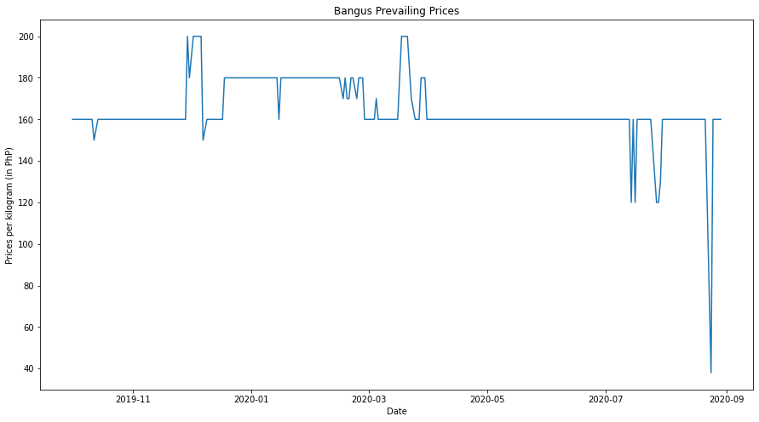Figure 1 reveals a time series visualization of the Bangus prices per kilogram from October 1, 2019 to August 31, 2020. Table 3 reveals the descriptive statistic and ADF test values.

Fig. 1. Bangus Prevailing Prices

After imputing the missing data, the Bangus prices had a maximum of 200 PhP and a minimum of 38 PhP. The mean price is determined to be 164.52 PhP.

Fig. 2. Bangus ITS Visualization

1. bangus prices Descriptive statistic and adf test value

| Statistic | Mean | Max | Min | ADF t-value | p-value |
| --- | --- | --- | --- | --- | --- |
| Value | 164.52 PhP | 200 PhP | 38 PhP | -5.98 | 0.0000001 |

The first step in the Box-Jenkins methodology which is testing for stationarity reveals the ADF to be less than 0.05 rejecting the null hypothesis. This means that the Bangus time series has no unit root and is stationary therefore the order of differencing **d** is 0. After determining the order of differencing, the next step is determining the order of **p** (AR) and order of **q** (MA) terms. The ACF plots reveals statistically significant lags while PACF displays a sharp cutoff at lag-2. After determining this, it is concluded that the ARIMA model would need 2 AR terms. After fitting the ARIMA model with the time series, each AR term is revealed to be statistically significant. Table 4 shows the summary of the ARIMA fitting.

1. ARIMA Fitting summary of bangus ITS

|  |  |  |  |  |
| --- | --- | --- | --- | --- |
|  | **coefficient** | **std. error** | **z-value** | **P>|z|** |
| **constant** | 169.0358 | 5.39 | 31.36 | 0 |
| **ar.L1** | 0.5859 | 0.087 | 6.764 | 0 |
| **ar.L2** | 0.2673 | 0.073 | 3.637 | 0 |
| **sigma2** | 44.6098 | 3.749 | 11.9 | 0 |
|  | | | | |
| **Ljung-Box (L1) (Q):** | 0.01 | | | |
| **Prob(Q):** | 0.92 | | | |

The Ljung-Box test accepts the null hypothesis indicating good fit. Each AR terms in the model is statistically significant. The residual diagnostics reveals a mean nearing zero, a normal distribution, and non-significant autocorrelations. By all indications in the study, ARIMA(2,0,0) is a good fit for the time series.

## Bangus ITS Fitting and Evaluation

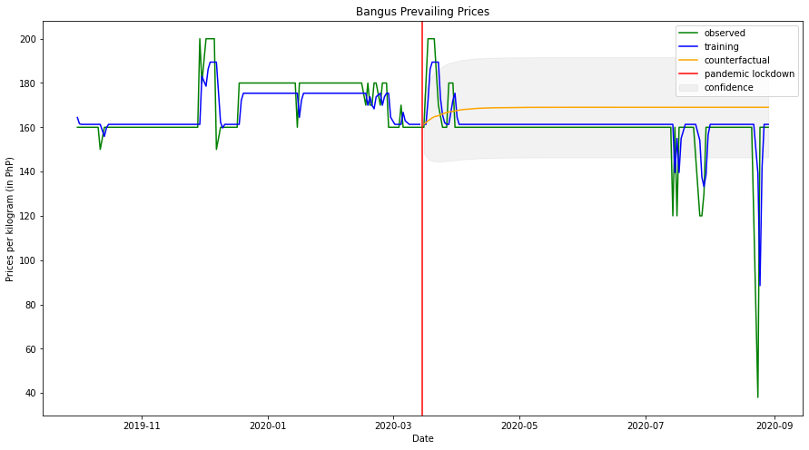After determining that ARIMA(2,0,0) is appropriate, the researcher modeled the counterfactual observation and the intervention point. Figure 2 shows a visualization of the ITS model.

The difference between the counterfactual and the training data shows a mean of -7.87, a max of 25.22 and a minimum of -80.54. Plotting the difference shows a change in expected prices during the months of March, April, July, and August of 2020 indicating an impact of the intervention during these months. The model itself was evaluated with RMSE showing a value of 10.79 indicating a minimal margin of error.

## Bangus Forecasting

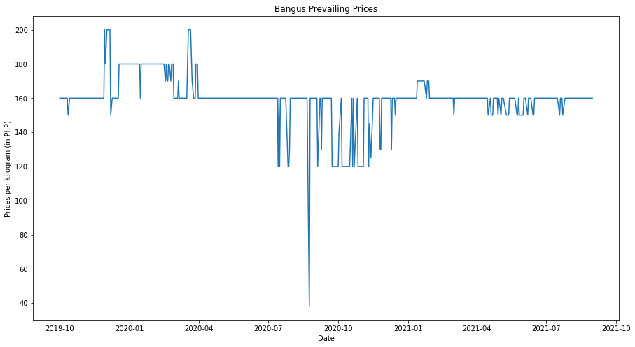Figure 3 displays the Bangus prices per kilogram from October 1, 2019 to August 31, 2021.

Fig. 3. Bangus Prevailing Prices (Forecasting)

After doing the same Box-Jenkins methodology for this time series, it was determined that the ADF p-value is more than 0.05 revealing that the time series is non-stationary. After differencing by an order of one and conducting another ADF test, the time series was determined to be stationary indicating that the order of differencing **d** for the model was one. After plotting the ACF and the PACF of the differenced time series, it displayed a sharp cut-off on the ACF plot at lag-1 concluding that the ARIMA model would need 1 MA terms. Table 5 reveals the summary of the ARIMA after fitting.

1. ARIMA Fitting summary of bangus Forecasting

|  |  |  |  |  |
| --- | --- | --- | --- | --- |
|  | **coefficient** | **std. error** | **z-value** | **P>|z|** |
| **ma.L1** | -0.4841 | 0.009 | -51.018 | 0 |
| **sigma2** | 98.1168 | 1.49 | 65.833 | 0 |
|  | | | | |
| **Ljung-Box (L1) (Q):** | 3.26 | | | |
| **Prob(Q):** | 0.07 | | | |

The Ljung-Box test accepts the null hypothesis indicating good fit. The MA term in the model is statistically significant. The residual diagnostics reveals a mean nearing zero, a normal distribution, and non-significant autocorrelations. By all indications in the study, ARIMA(0,1,1) is a good fit for the time series.

## Bangus Forecast Fitting and Evaluation

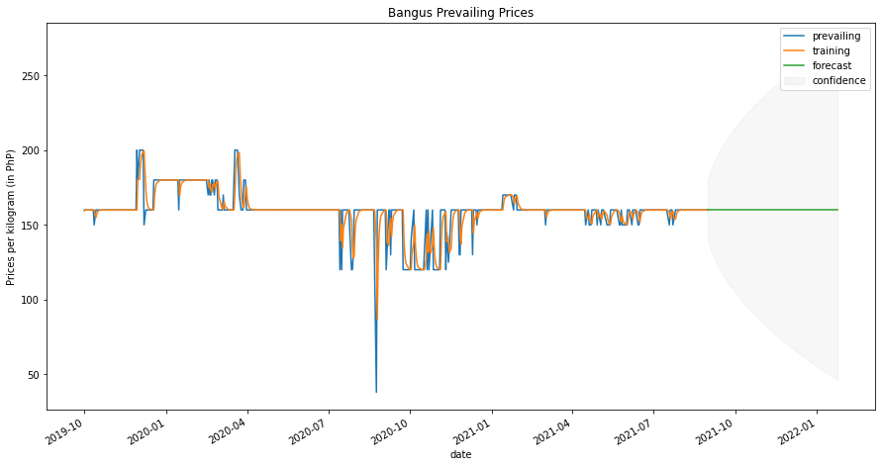After determining that the ARIMA(0,1,1) is a good fit for the time series, the researcher fitted the model and forecasted the prices until January 24, 2022. Figure 4 shows a visualization of the forecasting.

Fig. 4. Bangus Forecasting Visualization

## Tilapia ITS Analysis

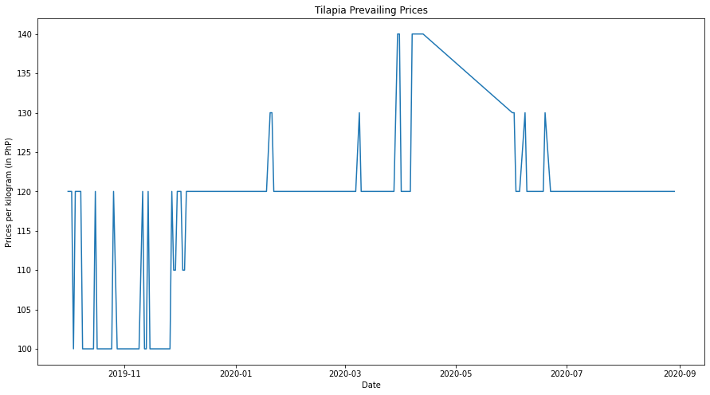Figure 5 reveals a time series visualization of the Tilapia prices per kilogram from October 1, 2019 to August 31, 2020. Table 6 reveals the descriptive statistic and ADF test values. After imputing the missing data, the Tilapia prices had a maximum of 140 PhP and a minimum of 100 PhP. The mean price is determined to be 120.13 PhP.

Fig. 5. Tilapia Prevailing Prices

1. tilapia prices Descriptive statistic and adf test value

| Statistic | Mean | Max | Min | ADF t-value | p-value |
| --- | --- | --- | --- | --- | --- |
| Observation | 120.13 PhP | 140 PhP | 100 PhP | -1.997 | 0.2878 |
| Differenced by one | | | | -4.59 | 0.0001 |

The first step in the Box-Jenkins methodology which is testing for stationarity reveals the ADF to be more than 0.05 accepting the null hypothesis. After differencing by an order of one and conducting another ADF test, the time series was determined to be stationary indicating that the order of differencing **d** for the model was one. After determining the order of differencing, the next step is determining the order of **p** (AR) and order of **q** (MA) terms. After plotting the ACF and the PACF of the differenced time series, it displayed a sharp cut-off on the ACF plot at lag-2 concluding that the ARIMA model would need 2 MA terms. After fitting the ARIMA model with the time series, each MA term is revealed to be statistically significant. Table 7 shows the summary of the ARIMA fitting.

1. ARIMA Fitting summary of Tilapia ITS

|  |  |  |  |  |
| --- | --- | --- | --- | --- |
|  | **coef** | **std. error** | **z-value** | **P>|z|** |
| **ma.L1** | -0.4915 | 0.009 | -51.018 | 0 |
| **ma.L2** | -0.1567 | 1.49 | 65.833 | 0 |
| **sigma2** | 19.5688 | 0.73 | 26.796 | 0 |
|  | | | | |
| **Ljung-Box (L1) (Q):** | 0.03 | | | |
| **Prob(Q):** | 0.85 | | | |

The Ljung-Box test accepts the null hypothesis indicating good fit. Each AR terms in the model is statistically significant. The residual diagnostics reveals a mean nearing zero, a normal distribution, and non-significant autocorrelations. By all indications in the study, ARIMA(0,1,2) is a good fit for the time series.

## Tilapia ITS Fitting and Evaluation

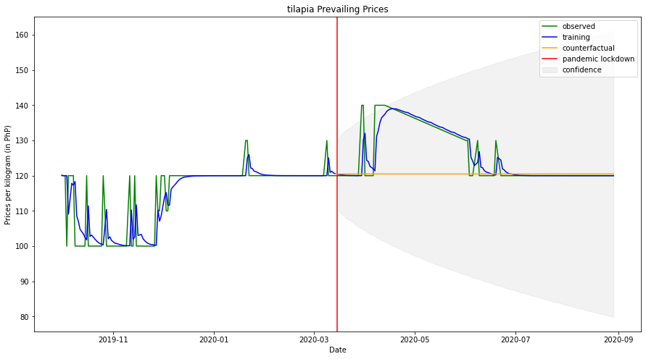After determining that ARIMA(0,1,2) is appropriate, the researcher modeled the counterfactual observation and the intervention point. Figure 6 shows a visualization of the ITS model

Fig. 6. Tilapia ITS Visualization

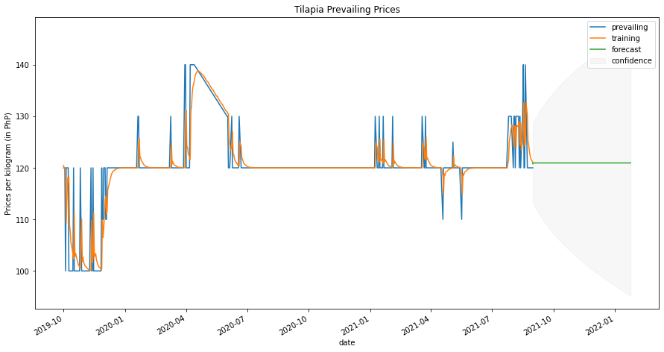The difference between the counterfactual and the training data shows a mean of 5.28, a max of 18.51 and a minimum of -0.48. Plotting the difference shows a change in expected prices during the months of April through June of 2020 indicating an impact of the intervention during these months. The model itself was evaluated with RMSE showing a value of 4.42 indicating a minimal margin of error.

## Tilapia Forecasting

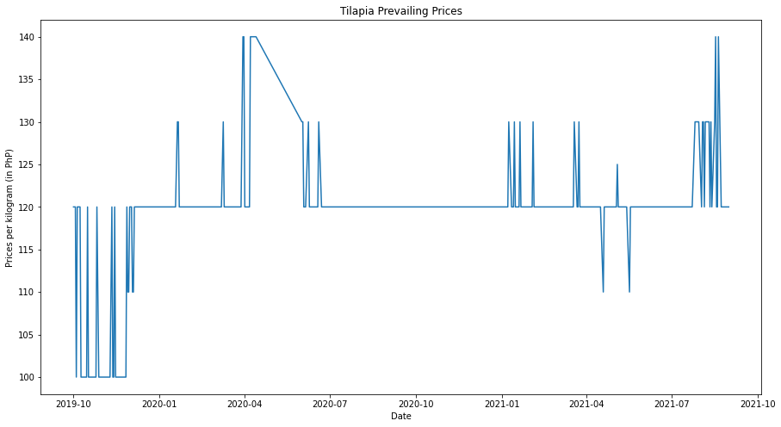Figure 7 displays the Tilapia prices per kilogram from October 1, 2019 to August 31, 2021

Fig. 7. Tilapia Prevailing Prices (Forecast)

After doing the same Box-Jenkins methodology for this time series, it was determined that the ADF p-value is less than 0.05 revealing that the time series is stationary. However, the ACF plot shows a high number of statistically significant autocorrelations meaning that differencing is necessary. After differencing by an order of one and conducting another ADF test, the time series was determined to be stationary indicating that the order of differencing **d** for the model was one. After plotting the ACF and the PACF of the differenced time series, it displayed a sharp cut-off on the ACF plot at lag-2 concluding that the ARIMA model would need 2 MA terms. Table 8 reveals the summary of the ARIMA after fitting.

1. ARIMA Fitting summary of Tilapia Forecasting

|  |  |  |  |  |
| --- | --- | --- | --- | --- |
|  | **coef** | **std. error** | **z-value** | **P>|z|** |
| **ma.L1** | -0.5152 | 0.021 | -24.460 | 0.000 |
| **ma.L2** | -0.1754 | 0.026 | -6.868 | 0.000 |
| **sigma2** | 13.1740 | 0.307 | 42.883 | 0.000 |
|  | | | | |
| **Ljung-Box (L1) (Q):** | 0.21 | | | |
| **Prob(Q):** | 0.65 | | | |

The Ljung-Box test accepts the null hypothesis indicating good fit. The MA terms in the model are statistically significant. The residual diagnostics reveals a mean nearing zero, a normal distribution, and non-significant autocorrelations. By all indications in the study, ARIMA(0,1,2) is a good fit for the time series.

## Tilapia Forecast Fitting and Evaluation

After determining that the ARIMA(0,1,2) is a good fit for the time series, the researcher fitted the model and forecasted the prices until January 24, 2022. Figure 8 shows a visualization of the forecasting.

Fig. 8. Tilapia Forecasting Visualization

## Local Round Scad ITS Analysis

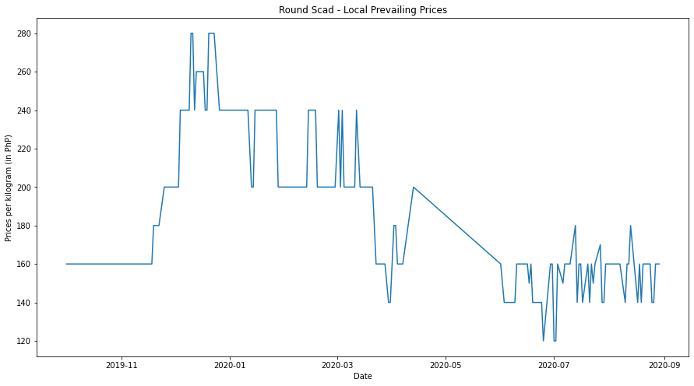Figure 9 reveals a time series visualization of the Local Round Scad prices per kilogram from October 1, 2019 to August 31, 2020. Table 9 reveals the descriptive statistic and ADF test values. After imputing the missing data, the Local Round Scad prices had a maximum of 280 PhP and a minimum of 120 PhP. The mean price is determined to be 184.27 PhP

Fig. 9. Local Round Scad Prevailing Prices

1. local round scad prices Descriptive statistic and adf test value

| Statistic | Mean | Max | Min | ADF t-value | p-value |
| --- | --- | --- | --- | --- | --- |
| Value | 184.27 PhP | 280 PhP | 120 PhP | -1.62 | 0.47 |
| Differenced by one | | | | -11.41 | 7.46 x 10-21 |

The first step in the Box-Jenkins methodology which is testing for stationarity reveals the ADF to be more than 0.05 accepting the null hypothesis. After differencing by an order of one and conducting another ADF test, the time series was determined to be stationary indicating that the order of differencing **d** for the model was one. After determining the order of differencing, the next step is determining the order of **p** (AR) and order of **q** (MA) terms. After plotting the ACF and the PACF of the differenced time series, it displayed a sharp cut-off on the ACF plot at lag-2 concluding that the ARIMA model would need 2 MA terms. After fitting the ARIMA model with the time series, each MA term is revealed to be statistically significant. Table 10 shows the summary of the ARIMA fitting.

1. ARIMA Fitting summary of Local Round Scad ITS

|  |  |  |  |  |
| --- | --- | --- | --- | --- |
|  | **coef** | **std err** | **z** | **P>|z|** |
| **ma.L1** | -0.2819 | 0.049 | -5.731 | 0.000 |
| **ma.L2** | -0.1595 | 0.041 | -3.881 | 0.000 |
| **sigma2** | 137.6129 | 7.157 | 19.229 | 0.000 |
|  | | | | |
| **Ljung-Box (L1) (Q):** | 0.02 | | | |
| **Prob(Q):** | 0.90 | | | |

The Ljung-Box test accepts the null hypothesis indicating good fit. Each AR terms in the model is statistically significant. The residual diagnostics reveals a mean nearing zero, a normal distribution, and non-significant autocorrelations. By all indications in the study, ARIMA(0,1,2) is a good fit for the time series.

## Local Round Scad ITS Fitting and Evaluation

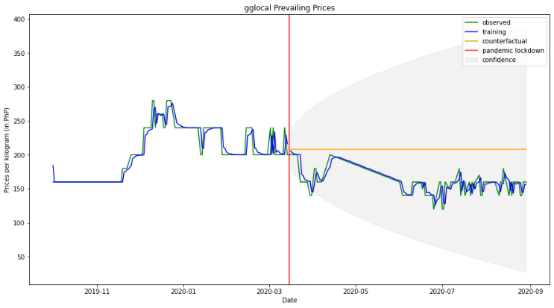After determining that ARIMA(0,1,2) is appropriate, the researcher modeled the counterfactual observation and the intervention point. Figure 10 shows a visualization of the ITS model.

Fig. 10. Local Round Scad ITS Visualization

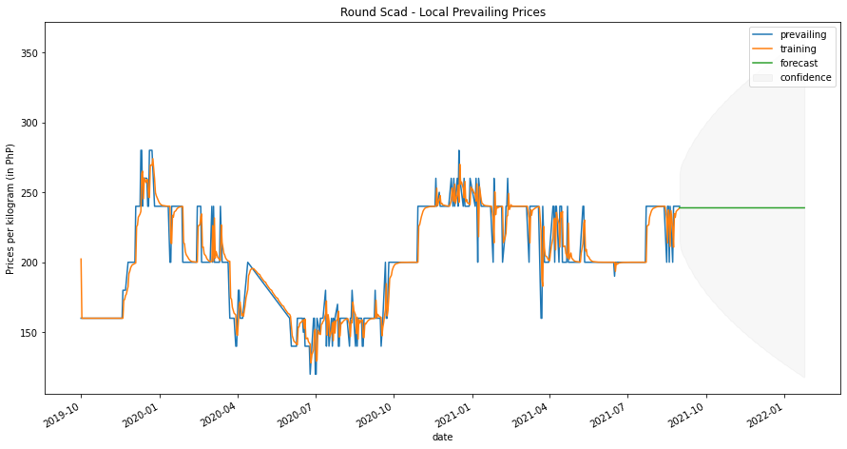The difference between the counterfactual and the training data shows a mean of -43.4, a max of 0.07 and a minimum of -82.20. Plotting the difference shows a change in expected prices during entirety of the pandemic lockdown indicating a large impact. The model itself was evaluated with RMSE showing a value of 11.797 indicating a minimal margin of error.

Fig. 12. Local Round Scad Forecasting Visualization

## Local Round Forecasting

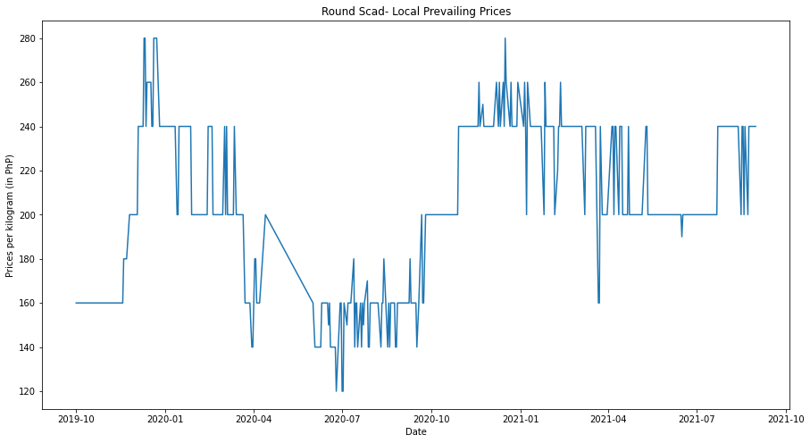Figure 11 displays the Local Round SCad prices per kilogram from October 1, 2019 to August 31, 2021.

Fig. 11. Local Round Scad Prevailing Prices (Forecast)

After doing the same Box-Jenkins methodology for this time series, it was determined that the ADF p-value is less than 0.05 revealing that the time series is stationary. However, the ACF plot shows a high number of statistically significant autocorrelations meaning that differencing is necessary. After differencing by an order of one and conducting another ADF test, the time series was determined to be stationary indicating that the order of differencing **d** for the model was one. After plotting the ACF and the PACF of the differenced time series, it displayed a sharp cut-off on the ACF plot at lag-2 concluding that the ARIMA model would need 2 MA terms. Table 11 reveals the summary of the ARIMA after fitting.

1. ARIMA Fitting summary of Local Round Scad Forecast

|  |  |  |  |  |
| --- | --- | --- | --- | --- |
|  | **coef** | **std err** | **z** | **P>|z|** |
| **ma.L1** | -0.3519 | 0.027 | -12.911 | 0.000 |
| **ma.L2** | -0.2092 | 0.031 | -6.799 | 0.000 |
| **sigma2** | 150.5871 | 5.048 | 29.828 | 0.000 |
|  | | | | |
| **Ljung-Box (L1) (Q):** | 0.02 | | | |
| **Prob(Q):** | 0.88 | | | |

The Ljung-Box test accepts the null hypothesis indicating good fit. The MA terms in the model are statistically significant. The residual diagnostics reveals a mean nearing zero, a normal distribution, and non-significant autocorrelations. By all indications in the study, ARIMA(0,1,2) is a good fit for the time series.

## Local Round Scad Forecast Fitting and Evaluation

After determining that the ARIMA(0,1,2) is a good fit for the time series, the researcher fitted the model and forecasted the prices until January 24, 2022. Figure 12 shows a visualization of the forecasting.

# Conclusions

Adopting the ARIMA model in analyzing the impact of the pandemic lockdowns proved to be effective in the case of fish commodity prices. The study concludes that there are impacts on the fish prices in specific months of the pandemic and the entirety of the pandemic in the case of the Local Round Scad. Each developed model was also effective in forecasting the fish prices given the amount a moderate amount of data points. Using the RMSE as the main evaluation criteria of accuracy for the both the forecasting and ITS analysis, the error is minimal and helps reinforce the validity of the model. Overall, the findings imply that from October 1, 2019 to August 31, 2021, the lockdowns have a statistically significant effect on the prices per kilogram of Bangus, Tilapia, and Round Scad in Metro Manila.

##### Refrences

|  |  |
| --- | --- |
| [1] | WHO Headquarters (HQ), "Report of the WHO-China Joint Mission on Coronavirus Disease 2019 (COVID-19)," World Health Organization, Geneva, 2020. |
| [2] | Department of Health , "COVID-19 CASE TRACKER," Department of Health, Manila, 2022. |
| [3] | FutureLearn, "The Philippines Economy and the Impact of COVID-19," 18 August 2021. [Online]. Available: https://www.futurelearn.com/info/futurelearn-international/philippines-economy-covid-19. [Accessed 5 February 2022]. |
| [4] | Food and Agriculture Organization of the United Nations, "Q&A: COVID-19 pandemic – impact on food and agriculture," 2022. [Online]. Available: https://www.fao.org/2019-ncov/q-and-a/impact-on-food-and-agriculture/en/. [Accessed 5 February 2022]. |
| [5] | A. S. M. Palo, M. A. Rosetes and D. P. Cariño, "COVID-19 and food systems in the Indo-Pacific: An assessment of vulnerabilities, impacts and opportunities for action," Australian Center for International Agricultural Research, Bruce ACT, 2020. |
| [6] | B. Beverly, "The continuing toll of the COVID-19 pandemic on farmers in the Philippines.," 19 May 2021. [Online]. Available: https://grameenfoundation.org/stories/blog/the-continuing-toll-of-the-covid-19-pandemic-on-farmers-in-the-philippines. [Accessed 5 February 2022]. |
| [7] | Department of Agriculture - Agriculture and Fisheries Information Division, "DA-ACPC lends initial P246 M under ‘Expanded SURE Aid’ loan program," 17 April 2020. [Online]. Available: https://www.da.gov.ph/da-acpc-lends-initial-p246-m-under-expanded-sure-aid-loan-program/. [Accessed 5 February 2022]. |
| [8] | Department of Agriculture - Agirbusiness and marketing Services Assistance, "Implementation Guide for Issuance of “Food Pass” Cards," 22 March 2020. [Online]. Available: http://agribusiness.da.gov.ph/2020/03/22/online-applications-for-food-pass-may-be-sent-thru-foodpass-agrigmail-com/. [Accessed 5 February 2022]. |
| [9] | Food and Agriculture Organization of the United Nations, "Rapid assessment of the impact of COVID-19 on food supply chains in the Philippines," FAO, Manila, 2021. |
| [10] | E. Bobeica and B. Hartwig, "The COVID-19 shock and challenges for time series models," European Central Bank, Frankfurt, 2021. |
| [11] | T. Daglis, K. N. Konstantakis and P. G. Michaelides, "The impact of Covid-19 on agriculture: evidence from oats and wheat markets," *Studies in Agricultural Economics,* vol. 122, no. 3, pp. 132-139, 2020. |
| [12] | N. T. Hung, "Oil prices and agricultural commodity markets: Evidence from pre and during COVID-19 outbreak," *Resources Policy,* vol. 73, no. 102236, pp. 1-10, 2021. |
| [13] | M. Hamulczuk and M. Skrzypczyk, "COVID-19, spatial market integration and producer prices: A case study of EU agri-food markets," *Studies in Agricultural Economics,* vol. 123, no. 2, pp. 53-61, 2021. |
| [14] | J. Goeb, P. Zone, N. Kham Synt, A. Zu, Y. Tang and B. Minten, "Food prices, processing, and shocks: Evidence from rice and COVID-19," *Journal of Agriculture Economics,* vol. 0, no. 0, p. 1–18, 2021. |
| [15] | G. Chitikela, M. Admala, V. Ramalingareddy, N. Bandumula, G. Ondrasek, R. Sundaram and S. Rathod, "Artificial-Intelligence-Based Time-Series Intervention Models to Assess the Impact of the COVID-19 Pandemic on Tomato Supply and Prices in Hyderabad, India," *Agronomy,* vol. 11, no. 1878, pp. 1-16, 2021. |
| [16] | Department of Agriculture, "Price Monitoring," 2022. [Online]. Available: https://www.da.gov.ph/price-monitoring/. [Accessed 5 February 2022]. |
| [17] | Y. Dong and C. Peng, "Principled missing data methods for researchers," *Springerplus,* vol. 2, no. 1, p. 222, 2013. |
| [18] | Labour Force Statistics, "Definitions," 5 September 2001. [Online]. Available: https://stats.oecd.org/glossary/detail.asp?ID=340. [Accessed 5 February 2022]. |
| [19] | S. JL and G. JW, "Missing data: our view of the state of the art," *Psychol Methods,* vol. 7, no. 2, pp. 147-177, 2002. |
| [20] | the pandas development team, "pandas.DataFrame.interpolate," 2022. [Online]. Available: https://pandas.pydata.org/docs/reference/api/pandas.DataFrame.interpolate.html. [Accessed 5 February 2022]. |
| [21] | G. E. P. Box, G. M. Jenkins, G. C. Reinsel and G. M. Ljung, Time series analysis: Forecasting and control, Nashville, TN: John Wiley & Sons, 2015. |
| [22] | R. Nau, "Statistical forecasting: notes on regression and time series analysis," 18 August 2020. [Online]. Available: https://people.duke.edu/~rnau/411arim.htm. [Accessed 5 February 2022]. |
| [23] | R. Hyndman and G. Athanasopoulos, Forecasting: Principles and Practice, Melbourne: OTexts, 2021. |
| [24] | W. Enders, Applied Econometric Time Series, 4th ed., Nashville, TN: John Wiley & Sons, 2014. |
| [25] | American Psychological Association, "APA Dictionary of Psychology - Interrupted Time Series Design," 2022. [Online]. Available: https://dictionary.apa.org/interrupted-time-series-design. [Accessed 5 February 2022]. |
| [26] | J. Ruan, Q. Cai and S. Jin, " Impact of COVID-19 and Nationwide Lockdowns on Vegetable Prices: Evidence from Wholesale Markets in China," *American Journal of Agricultural Economics,* vol. 103, no. 5, p. 1574–1594, 2021. |

**This study is not finished lmao tinamid ako magcheck**